OREM 7307/5307 – Fall 2022

***Smart Carbon Filter***

***Final Project Report***

*Prepared For*

***Prof. Rama Koganti***



*Prepared By*

***Team 1***

*[****Isabella Stojka, Hareish Raghupathy, Jose Barria****]*

*Date Submitted: 12/05/2022*

**Table of Contents**

**Project Description** **3**

**Objectives** **3**

**System Requirements** **3**

**System Life-Cycle** **4**

**Technical Performance Metrics (TPMs)** **5**

**Functional Flow Architecture** **6**

**Basic Design Sequence** **7**

**FMEA Analysis** **8**

**V Diagram** **8**

**Relationship Between TPM’s and Engineering Teams** **9**

**Design Definition Process** **10**

**Testing** **11**

**Test Plan** **11**

**Evolution of Test Requirements** **11**

**Validation** **12**

**Monte Carlo Simulation 14**

**References 15**

# 

# 

**1.Project Description**

Carbon dioxide in the atmosphere is increasing at a much faster pace than natural processes can remove, and oxygen is being produced. Excess amounts of CO2 in the atmosphere causes greenhouse gasses to rise and is a main contributor to climate change.

Industrial and manufacturing plants are one of the biggest sources of releasing pollutants into the atmosphere. In 2020, they released 5,981 Million Metric Tons of CO2 into the atmosphere. Industrial pollution causes ozone depletion, health problems to living organisms, and global warming. More and more manufacturing plants have been popping up as the economy is growing and more production of products is needed.

To battle this ongoing climate issue, our goal is to design and deploy a functional CO2 absorbing system that turns it into Oxygen or other gasses harmless to the environment. This will aid in the prevention of releasing harmful gasses into the atmosphere to not only hurt us but the environment as well.

# 

# **2.Objectives**

The main objective of our system is to filter out 90% of C02 chemicals that are released into the atmosphere by industrial plants. Our carbon filtration system size will be adaptable to fit into many chimneys to reach a large customer base. Our goal is for as many industrial plants to implement their product in their chimneys to ultimately reduce the amount of C02 that is being released into the atmosphere around the world.

# 

# **3.System Requirements**

Below the functional, non-functional and stakeholder requirements are stated to ensure success in our product. These requirements may be edited or added after testing is done.

*Functional Requirements:*

* The system shall absorb x amount of CO2 nanometers per hour.
* The system shall release x amount of 02 nanometers per hour.
* The system shall monitor the amount of CO2 in chimneys at all times.
* The system shall control the amount of CO2 in valves.
* The system shall contain a sensor that tracks the concentration of CO2 reached in the chimneys.
* The system shall contain an emergency valve that releases gasses at x pressure, this will prevent explosion.
* The system shall be adaptable to different filters.
* The filters shall be made of 100% recyclable materials

*Non-Functional Requirements:*

* The system shall be powered by existing electrical grid
* The system shall maintain efficiency 99% of the time
* The system shall last 5 years of performance usage
* The system shall send data to microcontrollers used in the factory with no more than 5 ms delay.

*Stakeholder Requirements:*

* The system shall be released before winter of 2023
* The final retail price of the system shall not exceed $5,000 USD
* The system shall not release more than 100,000 tons of CO2

# **4.System Life-Cycle**

The system life-cycle is displayed in figure 1 below. Our product will go through 8 stages which include planning, system analysis and requirements, development, integration and testing, implementation/production, utilization/support, and disposal.

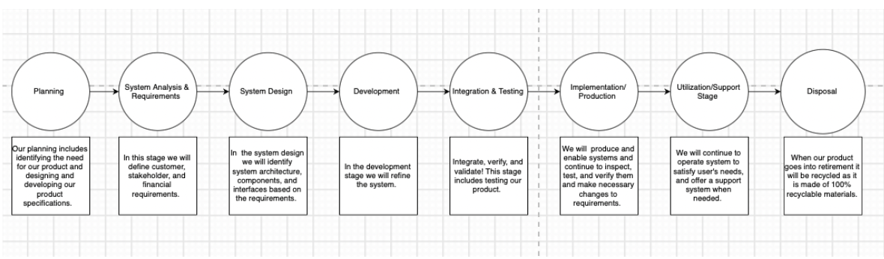

**Figure 1**: System Lifecycle

# 

# **5.Technical Performance Measures (TPMs)**

As technical performance measures (TPMs), or the applicable metrics, are established for the sys- tem, these measures must be allocated or apportioned to the next level, appropriate design criteria are identified, and these criteria must be reflected and supportive from the top down. Further, the appropriate methods/tools must be applied in the design process to ensure that the overall objectives of the system are met. Inherent within the system engineering process is the need to ensure that this traceability is maintained and to cause the integration of the appropriate techniques/methods/tools to facilitate the development process in an effective and efficient manner.

| **ID** | **Technical Performance Measure** | **Units** | **Planned** | **Goal** | **Threshold** |
| --- | --- | --- | --- | --- | --- |
| TPM.1 | Quantity of CO2 absorbed | nm per hour | 20 | 50 | 10 |
| TPM.2 | Quantity of O2 released | nm per hour | 20 | 50 | 10 |
| TPM.3 | Time for sending data to microcontroller | milliseconds | 3 | 2 | 5 |
| TPM.4 | Pressure of gas supported | hPa | 500 | 700 | 400 |
| TPM.5 | Recycled materials used in manufacturing process | % of recycled materials | 100 | 100 | 95 |
| TPM.6 | Final retail price of the product | $ USD | 4,500 | 4,000 | 5,000 |
| TPM.7 | Quantity of non-released CO2 | tons of CO2 per year | 50,000 | 25,000 | 100,000 |

# 

# **6.Functional Flow Architecture**

The functional flow representation of the system mechanism is shown below with 3 major levels:

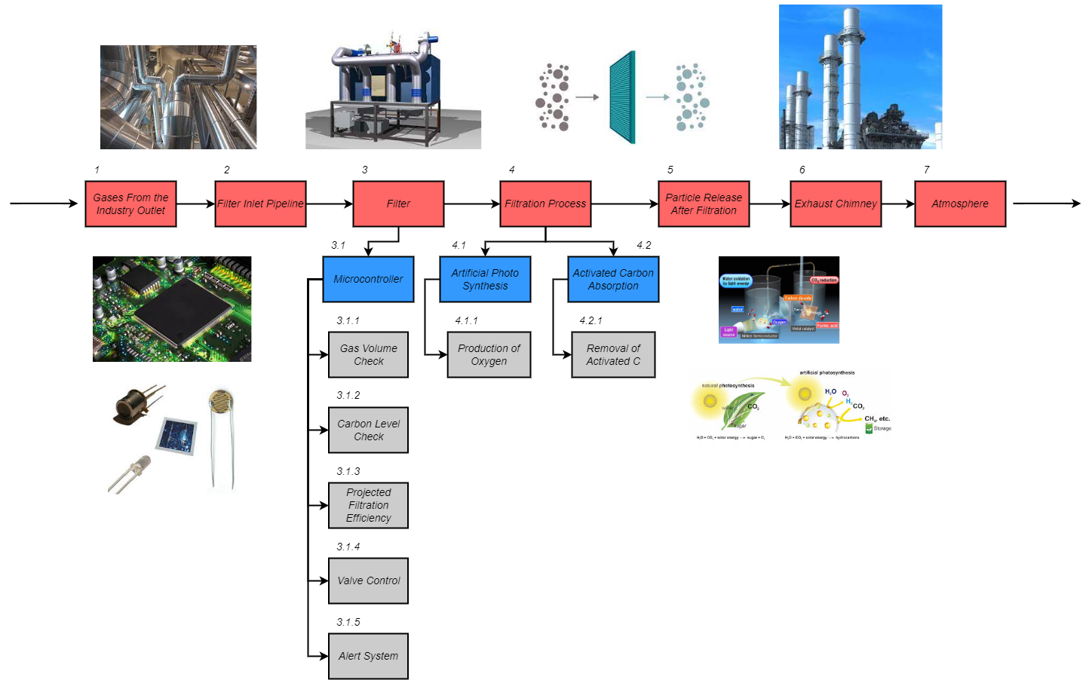

**Figure 2**: FFD

Step by Step Description:

* The unfiltered gasses from the industry pipeline enters the filter pipeline.
* The Inlet pipeline facilitates the flow of gasses to the filter.
* There is a microcontroller present in the filter which checks the contents and volume of the gas to provide data like the projected filtration efficiency or alert of there is unprecedented gas from the pipeline etc.
* It then controls the filter valve so that the filter works only when necessary to increase efficiency and reduce energy consumption.
* The filtration process after passing through the filter is done by two methods
  + Removal of Carbon from the Gasses
  + Conversion of C to O2 via Artificial Photosynthesis
* The filtered gas and oxygen is then sent through the exhaust pipe.
* Finally, the exhaust pipe then lets the filtered gas and converted-oxygen into the atmosphere.

# **7.Basic Design Sequence**

To review the steps in design further, the ‘basic design sequencediagram is presented as an amplification of functional flow architecture’diagram. As design progresses, actual definition is accomplished through documentation in the form of plans and specifications (already discussed), procedures, drawings, materials and parts lists, reports and analyses, computerized databases, and so on. The design configuration may be the best possible in the eyes of the designer; however, the results are practically useless unless properly documented so that others can first understand what is being conveyed and then be able to translate the output into a producible entity.

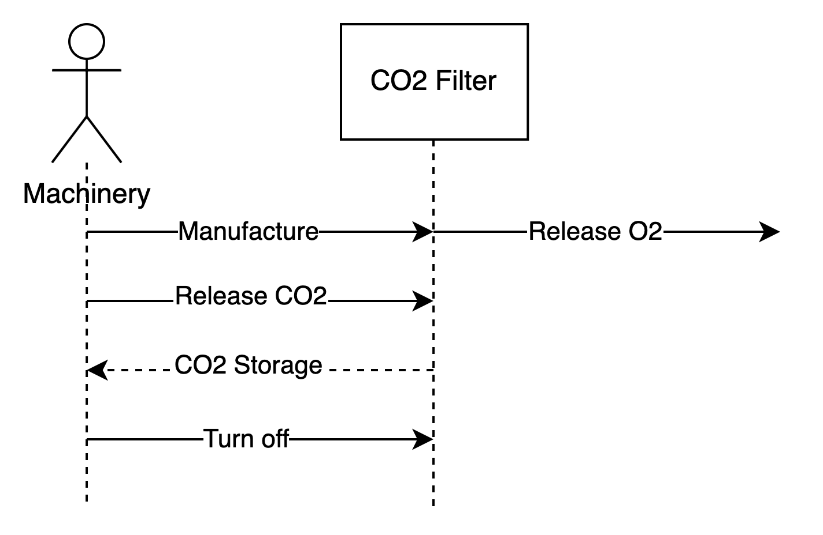

**Figure 3**: BDS

# **8.FMEA Analysis**

# A Failure Mode and Effects Analysis was conducted to address potential problems and failures and their potential effects on the system. Our goal in creating a FMEA was to provide insights on potential failures so we can prevent them before they occur.

# 

**Figure 4**: FMEA Analysis

# 

# **9.V Diagram**

The "V" diagram illustrates how the systems engineering approach identifies project requirements prior to selecting a technology and putting the system into place. The system definition moves from a broad user perspective of the system to a precise specification of the system architecture on the left side of the "V." For the completion of this project, we used the following “V” diagram structure, bearing in mind that it is crucial for pilots and tests to be rigorous.

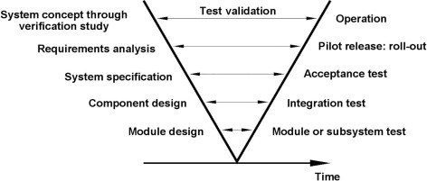

**Figure 5**: V-Diagram

# 

# **10.Relationship Between TPM’s and Engineering Teams**

In the parts that follow, we discuss design responsibility (and involvement in design reviews) from an organizational perspective. But now is a good time to think about some of the prerequisites for taking part in design reviews. For each significant system being constructed, a hierarchy of system evaluation criteria should be established and customized. The table below identifies those variables that are thought to be significant. In addition, a "degree-of-interest" relationship between the various technical performance measurements (TPMs) and the relevant disciplines involved in the design process can be formed.

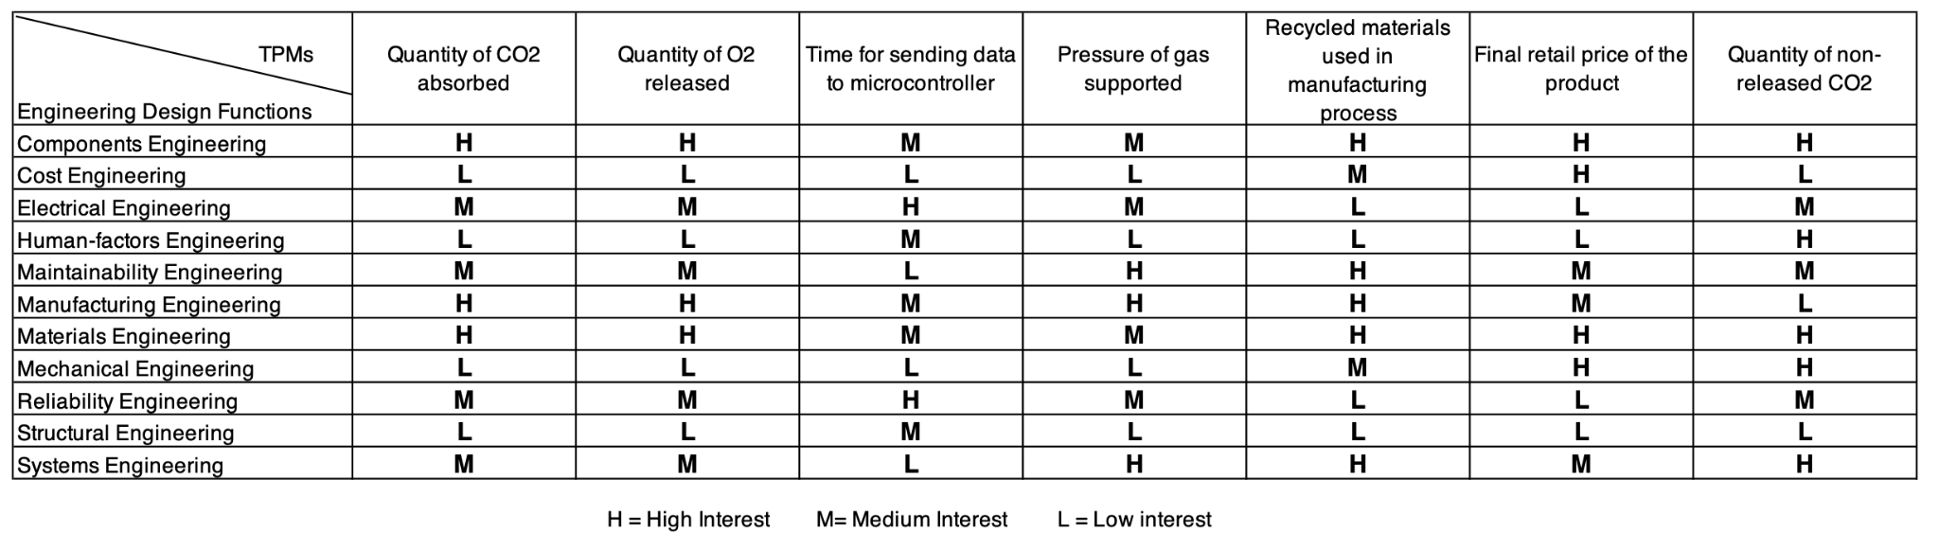

The level of interest indicated (i.e., high, medium, and low) pertains to the actual, or perceived, impact that the activity of the discipline has on a designated TPM for the system. This, in turn, should lead to establishing the organizational requirements for design review and evaluation as one progresses from conceptual design to the detail design and development phase.

# 

# **11.Design Definition Process**

Based on the steps in the basic design sequence, ideas are generated and converted to drawings (or equivalent), drawings are reviewed by various interested disciplines and/or organizations, recommended changes are initiated and incorporated as appropriate, and approved drawings (designated by drawing “sign-off”) are released for production. For the most part, the steps in this informal day-to-day process have been completed in series and often require a great deal of time. For instance, an electrical engineer may start the process with a proposed layout of components on a circuit board, a mechanical engineer may then provide the necessary structural and cooling requirements, a reliability engineer may follow with a prediction and evaluation of the selected components, and so on. These responsible individuals may be located in different geographical locations, and the data processing and communications often become quite lengthy. Further, this procedure takes on an additional degree of complexity as the number of drawings and drawing change notices increases.

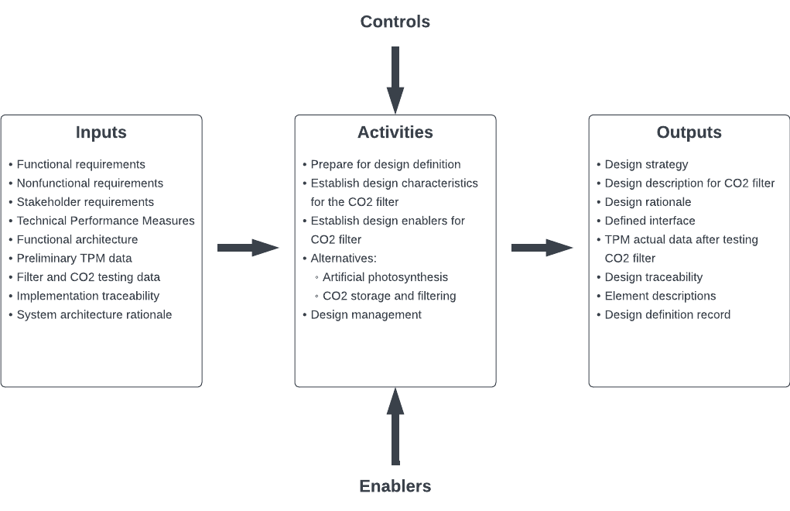

**Figure 6**: Design Definition

# **12.Testing**

After technical requirements are defined, test planning will begin. First, analytical and Simulation Evaluation CAD and analytical models will be used to verify certain designs.A three dimensional spatial model of the system will also be designed through computer graphics to show relationships among various systems and define design concepts early in the life cycle.

Type 1 testing will include testing of system components, mock-ups and rapid prototyping. Service test models will be built in effort to verify physical design and operational characteristics. Type 2 testing will include the evaluation of the prototype. Reliability tests will be done during this phase. Type 3 testing will conduct evaluation of the production models. Operational test and support equipment will be tested, operational software, and operational spares. Lastly, TPM’s will be verified and type 4 testing will ensue by continuous evaluation of the system in operational use.

# **13.Test Plan**

The test plan is very important as it lays out the road map for the work that must be completed during the project lifecycle. Our test plan is as follows:

1. Identify each test to be accomplished and each part in the system to be evaluated
2. Identify which organization will conduct each test and provide equipment and necessary support
3. Identify political, economic, and logistic factors to testing the system.
4. Create a description of each test phase including test method, procedures, and supporting personnel
5. Identify the formal test phase, analytical methods, requirements
6. Create a plan and associated provisions for retesting
7. Finalize a description of the final test report including feedback and recommendations for corrective actions

# **14.Evolution of Test Requirements**

Test planning should start when the technical specifications for the system are established, which occurs during the conceptual design phase. Testing evaluation and validation requirements are intuitive at an early stage since if a system needs to be established, then there must be a mechanism to measure and evaluate the system later to guarantee that the requirement has been met. A test and evaluation master plan (TEMP), initially created during the last stages of conceptual design, contains test planning and supporting objectives. The systems engineering management plan must be closely integrated with this strategy (SEMP).

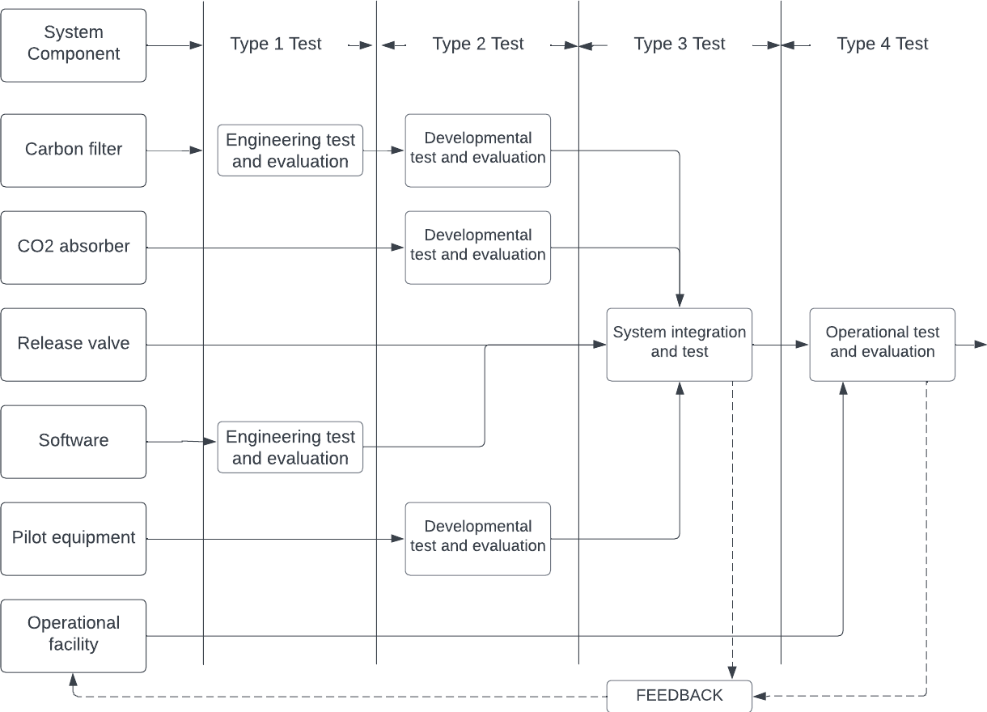

**Figure 7**: Evolution of Test Requirements

# 

# **15.Validation**

# Validation will be completed after the system is fully operational in the user’s environment. The system design configuration will be validated through a series of individual tests followed by an overall integrated system test and evaluation effort. System validation efforts include:

1. General System Operational and Support Factors
   1. Evaluation of operational scenarios
   2. Evaluation of system performance factors
   3. Verification of cost and system effectiveness
   4. Verification of logistics and maintenance support infrastructure
   5. Verification of system capability with other systems
2. Operational and Maintenance Software
   1. Verification of software reliability and maintenance characteristics
3. Operational and Maintenance Facilities
   1. Verification of the compatibility of maintenance software with other system elements
4. Transportation and Handling
   1. Evaluation of the reliability, maintainability, human factors, safety, security, and related characteristics of transportation and handling equipment
5. Personnel and Training
   1. Evaluation of personnel training policies and requirements
   2. Verification of operational personnel qualities and skill level depending on the industrial plant
6. Supply Support
   1. Evaluation of supply responsiveness (availability of spare parts)
   2. Evaluation of item replacement rates
7. Test and Support Equipment
   1. Verification of support equipment and quantity by operational level
   2. Verification of support equipment availability, reliability, and maintainability
   3. Evaluation of maintenance requirements for the support equipment
8. Technical Data and Information Handling
   1. Verification of the adequacy of the management and technical information capability
   2. Verification of adequacy, analysis, and corrective action
9. Consumer Response
   1. Evaluation of the degree of customer satisfaction
   2. Verification that the customer needs are being met

# **16.Monte Carlo Simulation**

A large class of computational techniques known as "Monte Carlo procedures" or "Monte Carlo experiments" rely on repeated random sampling to get numerical results. The core idea is to leverage randomness to find solutions to issues that, in theory, may be deterministic.

The following simulation was made for 250 iterations of random CO2 absorption levels (mean: 50 nanometers and std. Deviation of 20 nanometers):

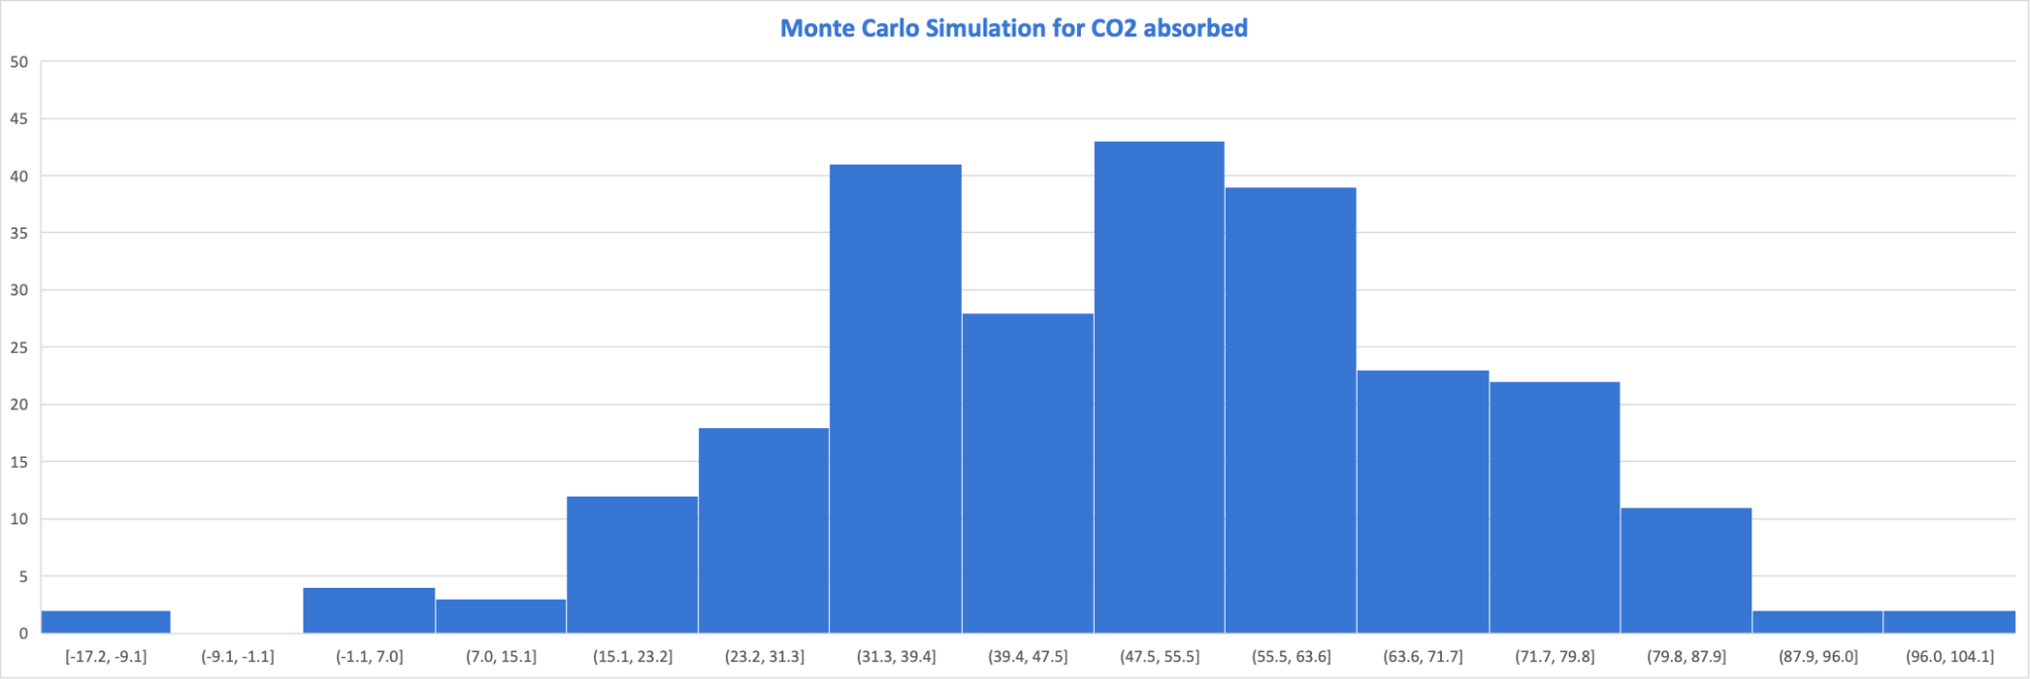

We observe that by following these principles we will have an attained absorbed CO2 of more than the planned threshold (10 nanometers). Therefore we can safely assume the filter will work under said conditions.

**Figure 8**: Monte Carlo Simulation

**17.References used for the Idea**

<https://www.pnas.org/doi/10.1073/pnas.0812721106>

<https://www.climate.gov/news-features/understanding-climate/climate-change-atmospheric-carbon-dioxide#:~:text=Without%20carbon%20dioxide%2C%20Earth's%20natural,causing%20global%20temperature%20to%20rise>.

<https://carbtrol.com/>

<https://books.google.com/books?id=WPVmCgAAQBAJ>

<https://www.weforum.org/agenda/2019/02/scientists-call-for-artificial-trees-to-fight-climate-change>

<https://www.trees.com/gardening-and-landscaping/best-carbon-filters-for-grow-rooms#TerraBloom-Premium-Carbon-Filter>

_____________________________________________________________________________________

***End of Report***